The OIE Communication Toolbox on the fight against antimicrobial resistance
www.oie.int/antimicrobial-resistance

SELECTION- click on the icones
NEW OIE web portal on antimicrobial resistance  (last update: November 2015)  Available in FR, EN, ES  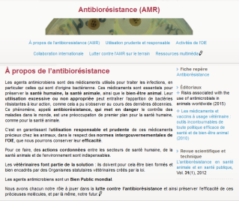  This platform gathers ample information on the responible and prudent use of antimicrobial agents and OIE activities in this domain  - It makes reference to all OIE documents : factsheets, intergovernmental standards, resolutions, press releases, posters, infographics.  - An entire page is dedicated to OIE communication tools targeted at diferent audiences. |  | NEW Infographics on “Responsible and prudent use of antibiotics”  Available in FR, EN, ES  Objectives  - Raise awareness on the need to preserve the efficacy of antibiotics  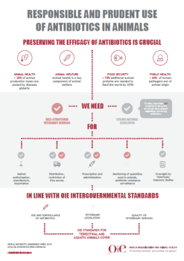  - Promote the role of Veterinary Services and the importance of the implementation of appropriate national legislation
NEW Posters on “Fighting antibiotic resistance: what can you do ?”
Available in FR, EN, ES
Objective: provide 5 key messages to the audiences concerned
Available visuals for each poster : poultry – swine – aquatic animals – dog
Within the framework of the “Antibiotics : handle with care “campaign
National authorities  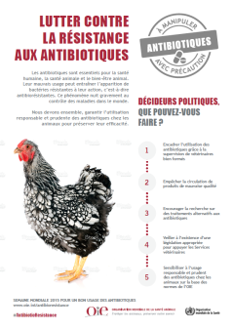 | Veterinarians  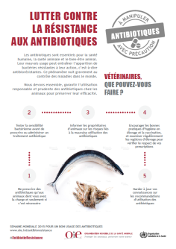 |  | Breeders and dog owners  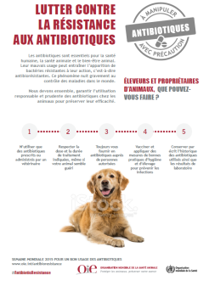
Antimicrobial resistance: Summary of OIE activities  (last update: July 2015)  Available in English  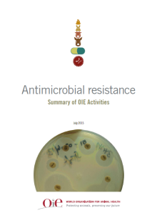 | OIE factsheet on antimicrobial resistance  (last update: May 2015)  Availabe in FR, EN, ES  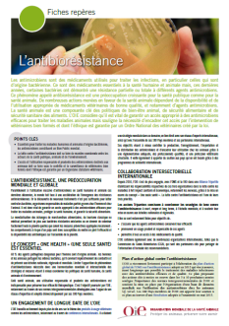 |  | FAO/OIE/WHO tripartite factsheet on the fight against antimicrobial resistance  Available in English  